ATTACHMENT-3
INFORMATION DOCUMENT ABOUT THE LAUNCH PAD
All rockets in TEKNOFST Rocket Competition will be launched from the launch pad to be provided by the Competition Committee.
DEFINITION:
LAUNCH RAIL: The launch mast from which the rocket will be launched is inclined at a set angle to the ground, in accordance with the competition arrangements.
The horizontal and vertical images of these launch pads are shown together in Figure 1.
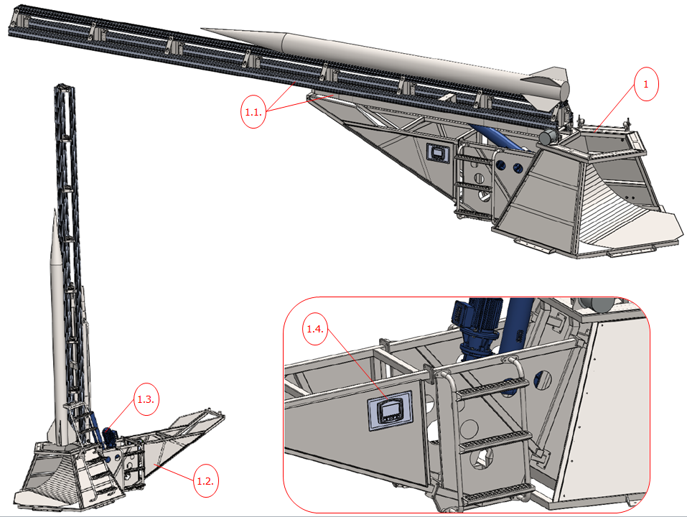
Figure 1. Launch Pad Horizontal and Vertical Positions
Competitors will place their rockets on the ramp using the Rail Buttons. The definition of the Launch Ramp in the contract is given below:
RAIL BUTTON: A manual component that is mechanically attached to the rocket’s frame and that ensures the rocket is positioned linearly on the launch rail. The rocket frame is mounted with at least two rail buttons on a straight line. The teams are responsible for the integration of the rail buttons onto the rocket frame. The placement of the rail buttons will be checked by the competition referees.
Competitors are not allowed to manufacture their own rail buttons. The rail buttons will be handed over to the contestants by the Competition Committee during integration day in Aksaray Hisar Firing Test Range. The rail buttons have been designed to be fixed using an “M4 Countersunk Bolt”.
M4 Countersunk Bolts will not be provided by the Competition Committee. The teams must procure such bolts before the integration activities (before arriving at the Aksaray Hisar Firing Test Range). An isometric view of the Rail Button is shown in Figure 2, with a cross-sectional view and dimensions detailed in Figure 3.
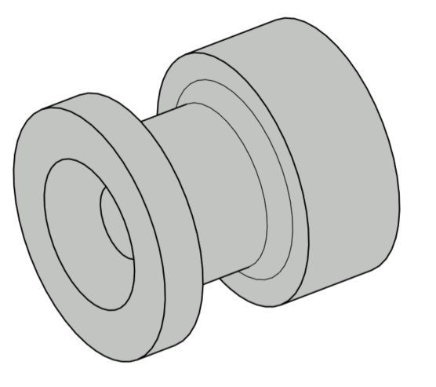
Figure 2. Rail Button Isometric View
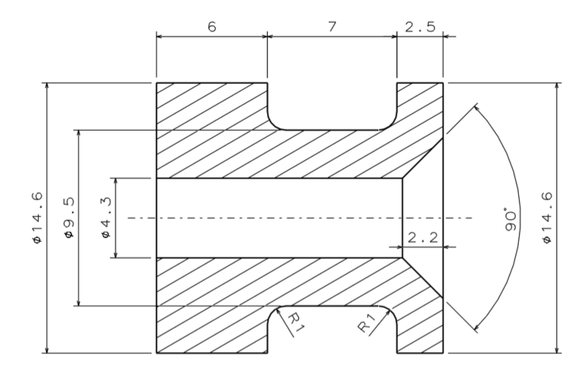
Figure 3. Rail Button Cross-Sectional View
The mounting of the Rail Button onto the rocket using an M4 Countersunk Bolt is depicted with Figure 4. The mounting point of the Rail Button shall not be in line with any projections, such as fins, antenna, etc. along the longitudinal axis of the rocket. All teams are expected to consider these issues carefully, and to ensure that their rocket is properly mounted on the ramp, taking into account all requirements of the competition contract.
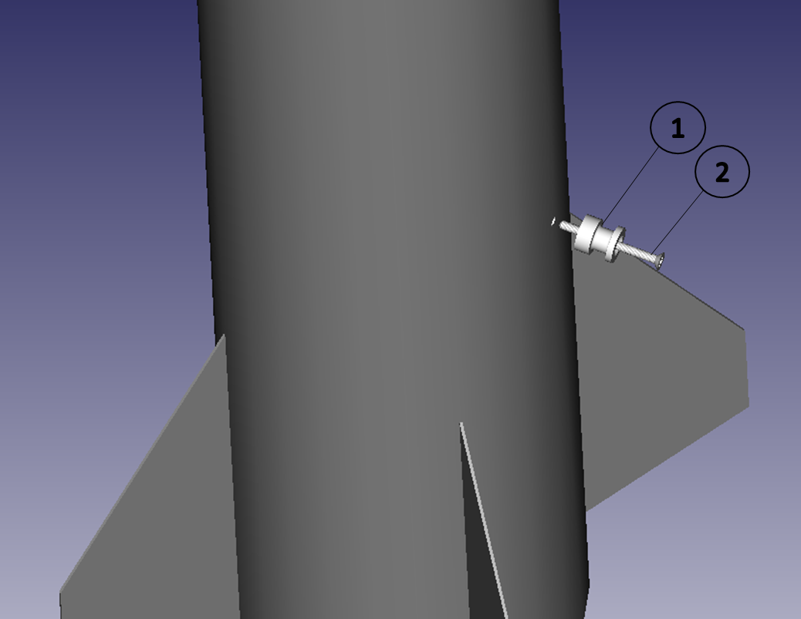
1. Rail Button
2. M4 Countersunk Bolts
Figure 4. Mounting of the Rail Button on the Rocket
The position of the rail button should permit the easily mounting of the rocket on the ramp. The mounting of the rocket on the ramp is entirely the responsibility of the competitors. A model of the ramp that will be used for the launch can be found in the integration area, on which the competitors can test the suitability of their rockets.
The position of the rocket on the launch rail and the rail button are shown in Figure 5 as an example.
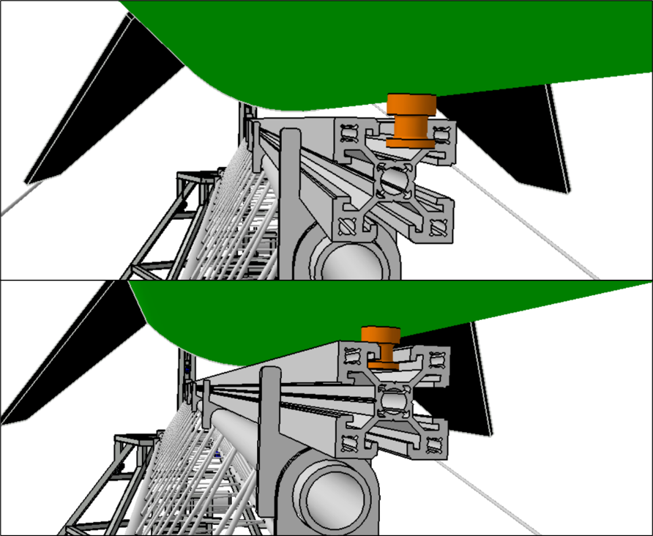
Figure 5. Rocket with Rail Buttons Attached on the Launch Pad (REPRESENTATION)
A rocket launched onto a ramp will come to a stop as shown in Figure 6. In the related image, the rail buttons are indicated with a red circle.
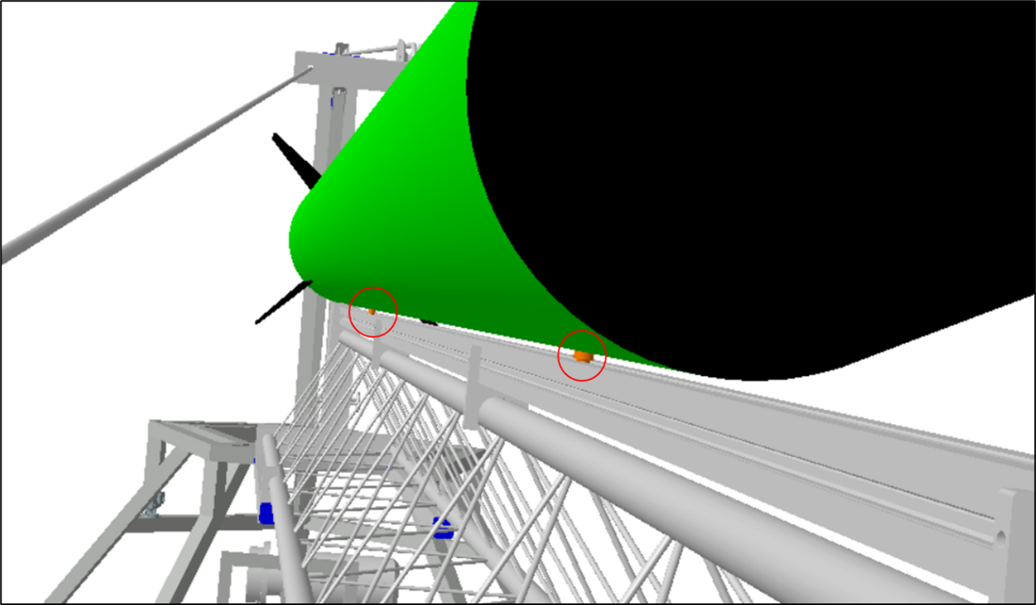
Rails Buttons are indicated in red circles.
Figure 6. Rocket on a Launch Ramp (View from Below) (REPRESENTATIVE)

